SOFTWARE DOCUMENTATION REPORT
Project Name: Fundify Professional Banking Portal Phase: SDLC Phase 8 - Documentation (User Manual, Technical Specs, and Test Reports)
PART 1: USER MANUAL
A step-by-step guide for customers using the Fundify Portal.
1. Getting Started (Login)
- Open your web browser and navigate to the portal.
- You will be greeted by the secure login screen.
- Enter your registered Username and Password (Default: admin / admin123).
- Click Secure Login to access your dashboard.
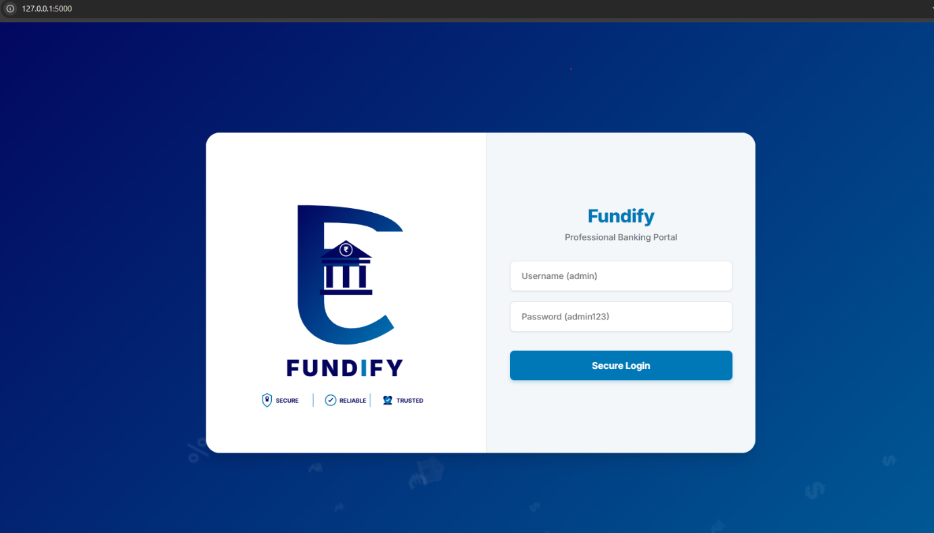

2. Dashboard & Navigation
- The main dashboard provides a quick overview of your "Savings Balance" and "Credit Card Outstanding Balance".
- Click the Eye Icon next to your balance to securely hide or show your funds.
- Use the navigation tabs across the middle of the screen to switch between: Banking, Cards, Loans, Invest, Rewards, FAQ, and About.
3. Making a Transaction (Banking Tab)
- Navigate to the Banking tab.
- Click on any service, such as Quick Transfer or Mobile Recharge.
- A "Send Money" window will appear. Enter the recipient's details and the amount you wish to send, then click Proceed to Pay.
- You will be prompted to enter your 4-digit secure UPI PIN using the on-screen number pad.
- Upon success, a green notification will appear, and your balance will automatically update.
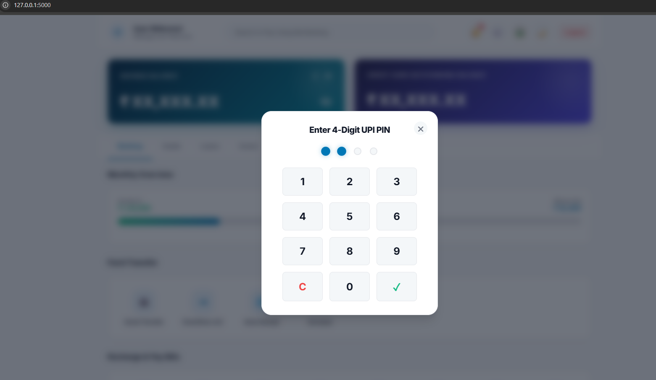

4. Managing Cards & Loans
- Cards: Navigate to the Cards tab to view your virtual debit card. You can use the interactive toggle switches to instantly freeze your card or disable International/Online transactions.
- Loans: Navigate to the Loans tab to view your active loans or use the interactive Loan Calculator to estimate future EMI payments.
5. Personalization & Settings
- Dark Mode: Click the Moon icon (🌙) in the top right corner to switch the entire application to an eye-friendly Dark Mode.
- Custom Backgrounds: Click the Picture icon (🖼️) in the top right corner to open the theme selector and choose a custom dashboard background.
- Context Menu: Right-click anywhere on the dashboard to open a custom quick-action menu to jump to payments or settings.
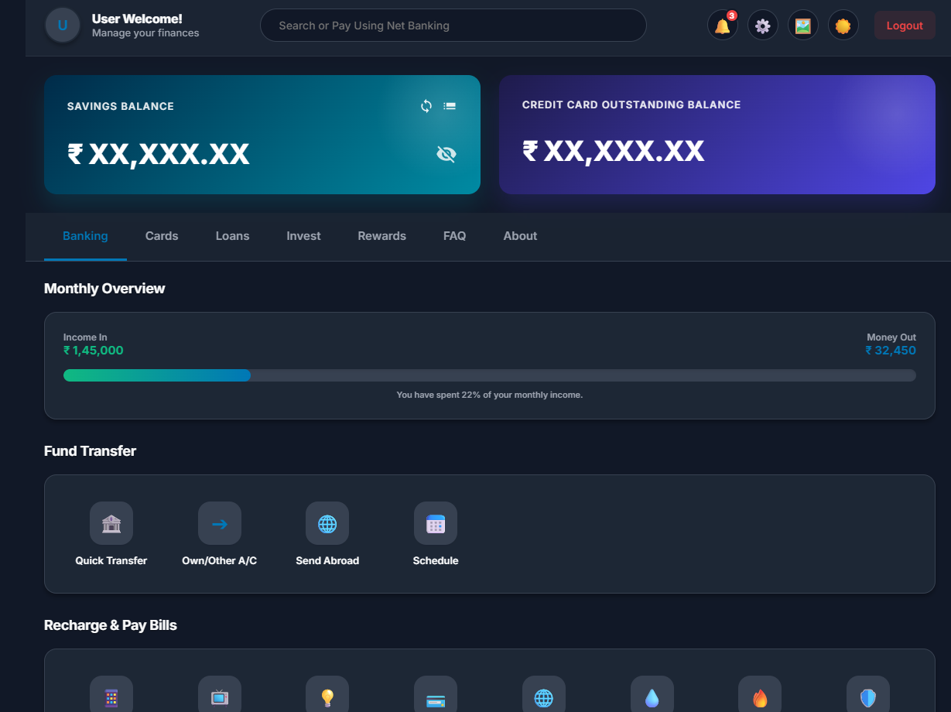
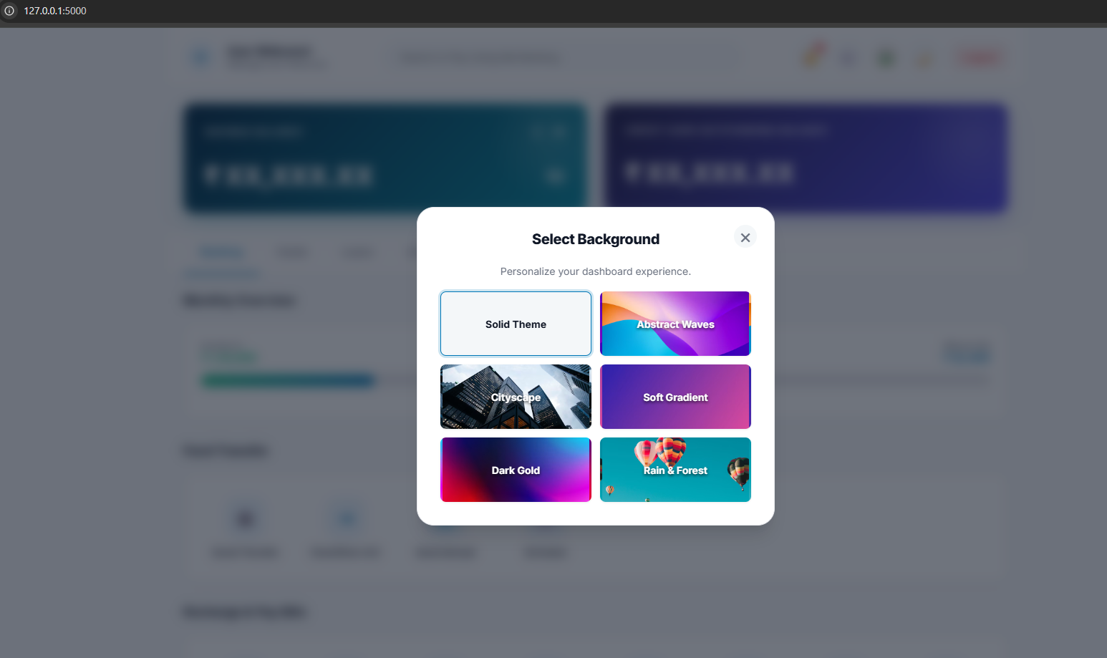

PART 2: TECHNICAL DOCUMENTATION
Architecture, Technology Stack, and Security Implementation for Developers.
1. System Architecture The Fundify application follows a modern Client-Server architecture utilizing a Single Page Application (SPA) design on the frontend, communicating asynchronously with a RESTful API backend.
2. Technology Stack
- Frontend (Client-Side): HTML5, CSS3 (with CSS Variables for dynamic theming), and Vanilla JavaScript. The UI employs modern "Glassmorphism" design principles (using backdrop-filter).
- Backend (Server-Side): Python 3 and the Flask Web Framework.
- Database: SQLite3 (A lightweight, disk-based relational database).
3. Database Schema The system auto-initializes a relational database (fundify.db) upon first launch.
- users table: Stores id, username, password (hashed), and balance.
- transactions table: Stores id, user_id (Foreign Key), recipient_name, amount, and timestamp.
4. Security Implementation Security was integrated natively into the backend following SDLC best practices:
- Authentication: Managed via Flask server-side session objects.
- Data Encryption: Passwords are never stored in plain text. They are mathematically encrypted and salted using Werkzeug's generate_password_hash (PBKDF2/Bcrypt) before being saved to the database. Logins are verified securely using check_password_hash.
- Injection Prevention: All database queries utilize parameterized inputs (?) to completely prevent SQL Injection attacks.
- Data Validation: The backend automatically intercepts and rejects invalid data (e.g., attempting to send a transaction with an amount of 0 or negative values).
PART 3: TEST REPORTS
Summary of Backend Automated Testing via Pytest.
Testing Framework Used: pytest (Python Testing Framework) Testing Level: API Integration & Unit Testing
To ensure the reliability of the financial backend, an automated test suite (test_app.py) was created to simulate application requests.
Test Execution Results: All core modules successfully passed automated testing with zero failures.
- test_valid_login - PASSED
  - Action: Sent a POST request with correct admin credentials.
  - Result: Server correctly authenticated the user, returned HTTP 200 OK, and provided the user's secure session balance.
- test_invalid_login - PASSED
  - Action: Sent a POST request with incorrect credentials.
  - Result: Server correctly rejected the login and prevented access.
- test_get_transactions - PASSED
  - Action: Sent a GET request to the transactions API endpoint.
  - Result: Server successfully retrieved the transaction history from the SQLite database and returned it as a valid JSON array.
- test_create_transaction - PASSED
  - Action: Sent a POST request to initiate a new money transfer.
  - Result: Server verified the balance, recorded the transaction, deducted the funds, and returned HTTP 201 Created.
- test_empty_transaction - PASSED
  - Action: Sent a POST request attempting to transfer ₹0.
  - Result: Server security checks successfully caught the invalid logic and rejected the transaction, returning an HTTP 400 Bad Request error.
